

**Department of Computer Engineering**

**Academic Year 2021-2022**

**"Abhiyanta" Newsletter**

**For Odd Semester, Volume 1**

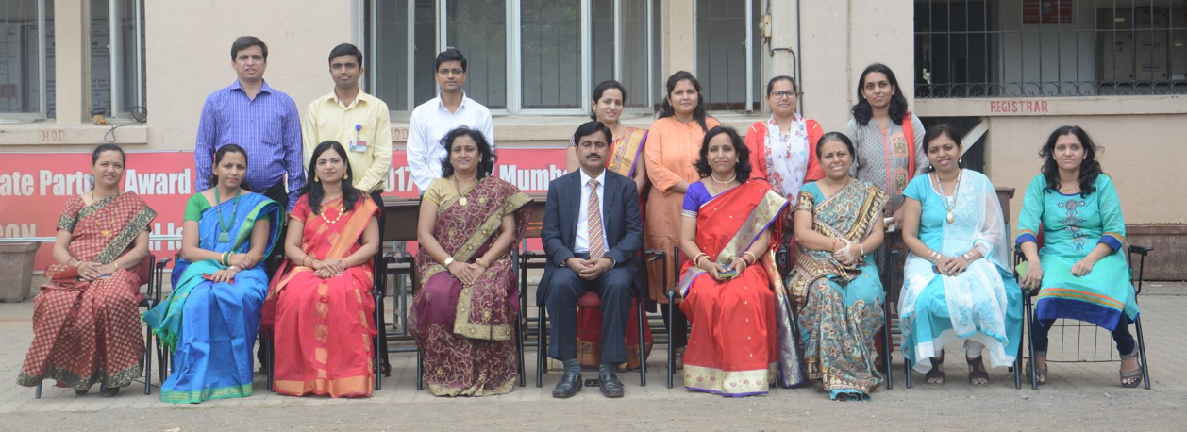

**About Department:**

The Computer Engineering department was established in the year 2001 for providing excellent education to all students with an aim to foster creativity in Learning, research and building a knowledge base along with imparting quality education. The department possesses well qualified and motivated faculty members and support staff. The laboratories are adequately equipped with state-of-the-art facilities. The department offers add-on courses to cope with the latest trends in technology. It organizes industry visits and many series of expert lectures for the students on the latest developing trends in Computer Industry. Students of our department have won prizes in various national and international level paper presentation competition and project exhibitions. Every year a remarkable number of students place in companies such as Infosys, TCS, Accenture, Cognizant, L&T Infotech, CSC, Tech Mahindra, Mastek, TPG Axon, Artistivity etc.

**Vision:**

*To be the finest centre of learning by imparting quality teaching in the field of computer engineering.*

**Mission:**

*To inculcate in student the ability to analyse, design and develop software projects.*

*To prepare students to be ready for ever changing scenario in the field of Computer Engineering.*

*To help the students to attain and utilize their potential for successful carrier and to the need of society and industry.*

**Program Educational Objectives (PEOs):**

Students will possess:

PEO 1: *Sound knowledge of mathematics, science and engineering fundamentals required for a lifelong career in computer engineering domains.*

PEO 2: *Skill to design and develop software projects for solving real world problems with the use of modern tools and techniques.*

PEO 3: *Professional ethics, leadership qualities and social awareness in the students.*

**Highlights of the Department**

 **Dr. Hiral Shah**: Lorem ipsum dolor sit amet, consectetur adipiscing elit. Curabitur pulvinar dignissim ex.

 **Dr. Jai Shah**: Donec nunc leo, accumsan pretium nisl ac, bibendum fringilla ligula.

 **Dr. Sarvesh Soni**: Aliquam erat volutpat. In eget facilisis orci. Aenean iaculis euismod nulla, nec convallis diam ornare volutpat.

**Remarkable Milestones:**

**1. Remarkable Milestones Title 1**

Curabitur venenatis, nibh quis pharetra tincidunt, odio nisl sollicitudin justo, vel efficitur odio urna eu libero.

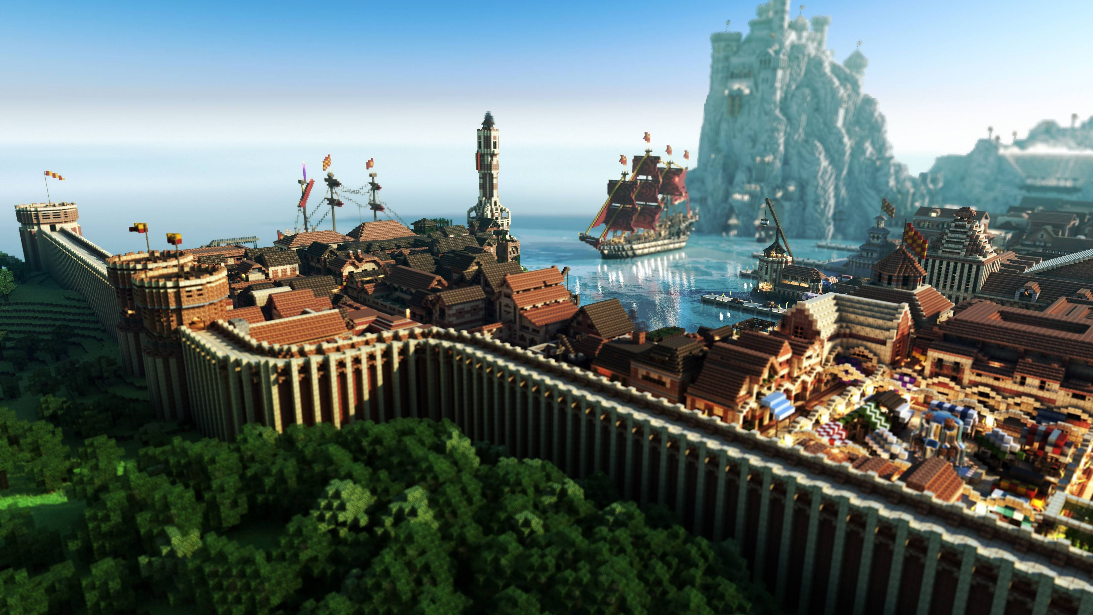

**2. Remarkable Milestones Title 2**

Praesent id urna arcu. Curabitur ultricies enim ac sapien dictum, non lacinia metus tincidunt. Nulla tellus urna.

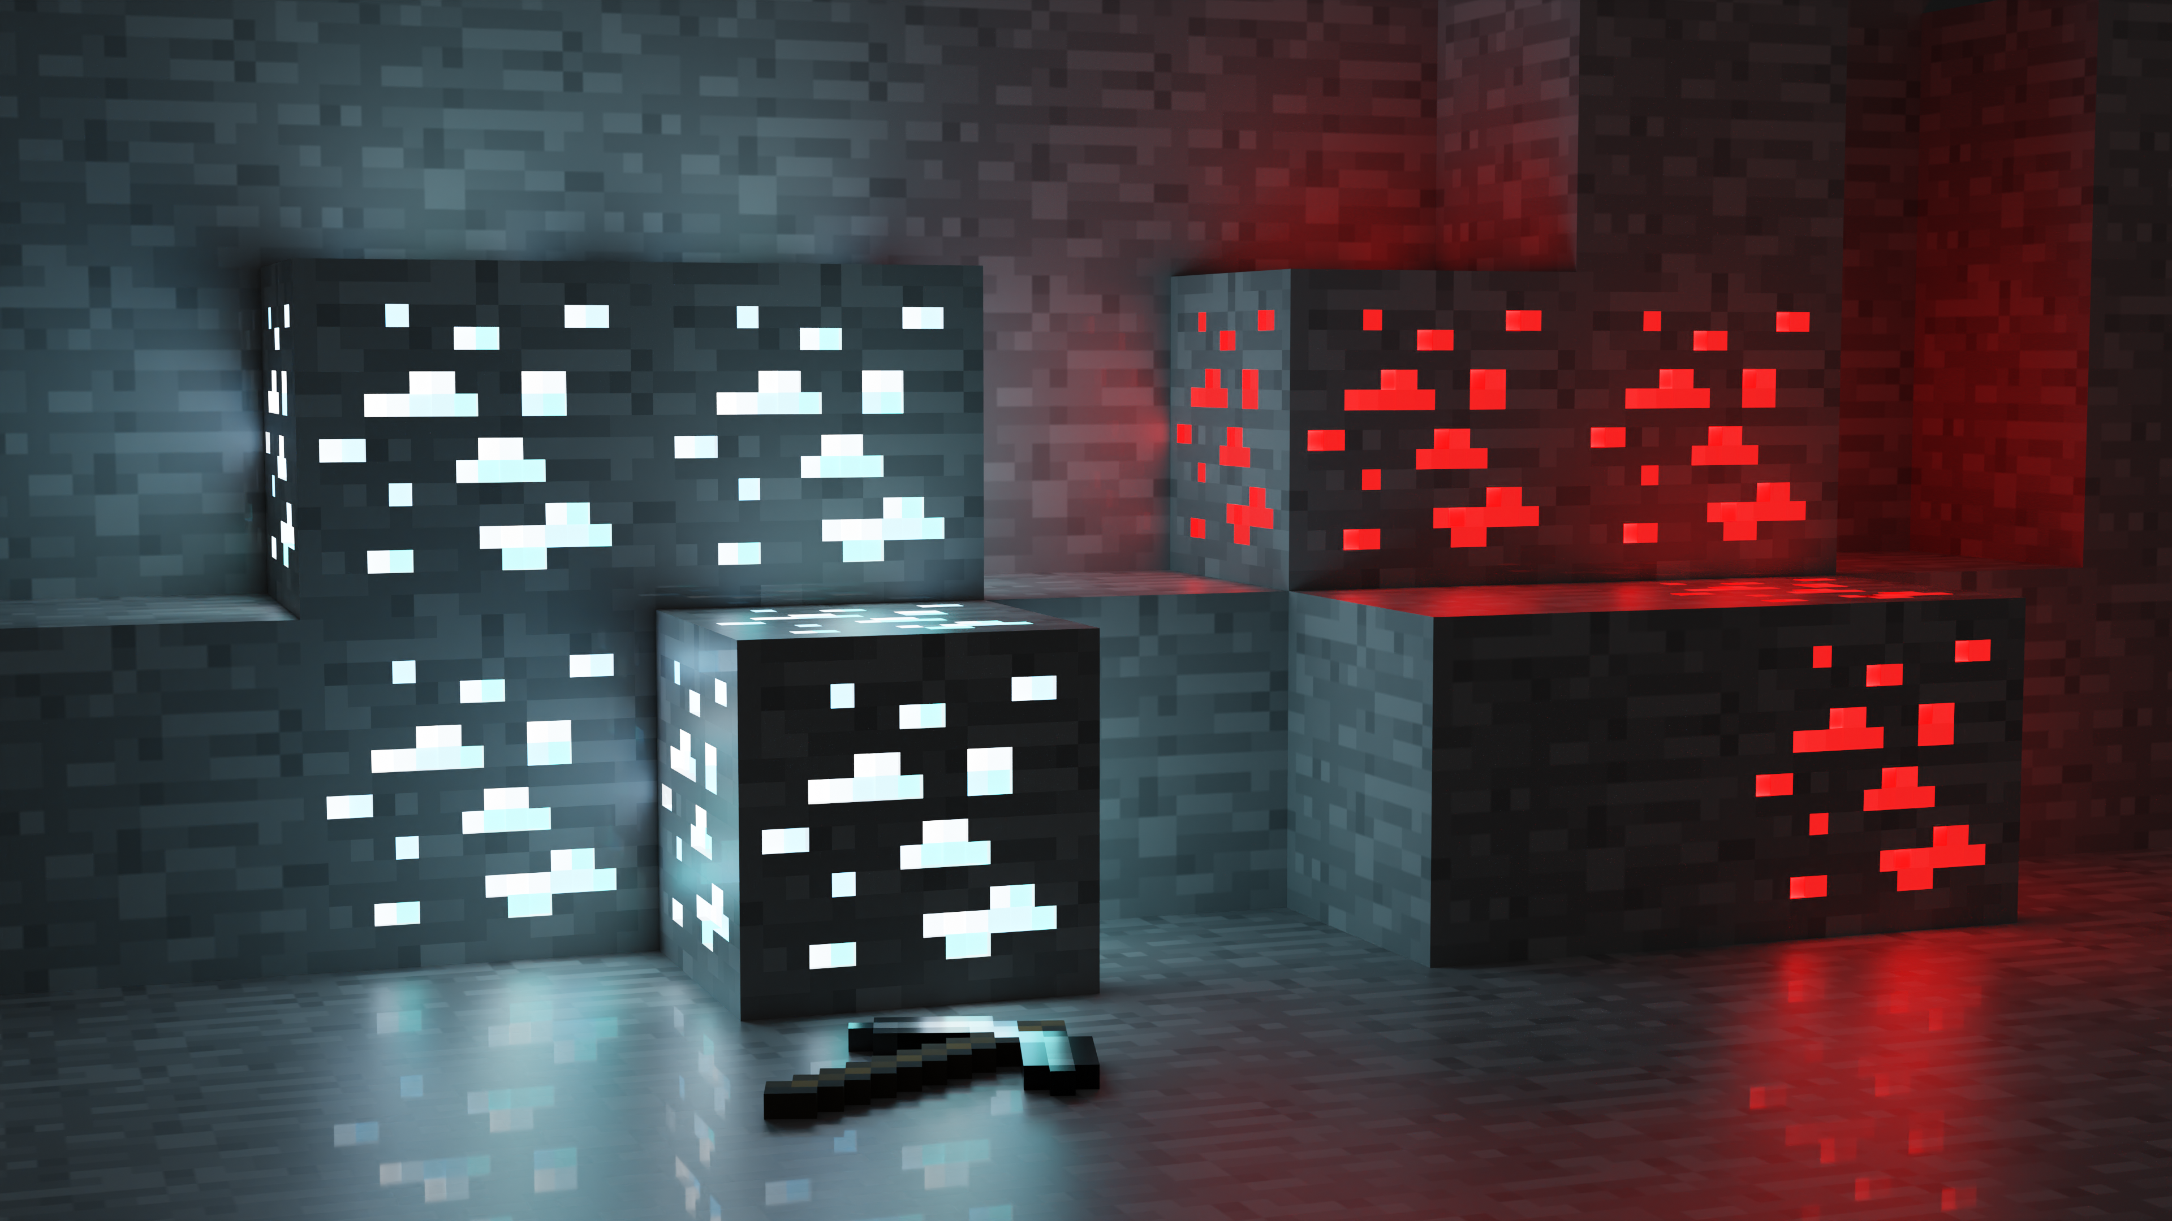

|  |  |
| --- | --- |
|  |  |
| **Placement Statistics** | **Result Statistics** |
|  |  |
| **Percentage of placement in various Companies** | **Percentage of Students Passed** |

**Student Achievements**

**1. Student Achievements Title 1**

Student Achievements Content 1: Curabitur venenatis, nibh quis pharetra tincidunt, odio nisl sollicitudin justo, vel efficitur odio urna eu libero.

**Team Members:**

|  |  |
| --- | --- |
| 1. Sarvesh | 2. Jai |
| 3. Hiral | 4. Sarvesh |



**2. Student Achievements Title 2**

Student Achievements Content 2: Praesent id urna arcu. Curabitur ultricies enim ac sapien dictum, non lacinia metus tincidunt. Nulla tellus urna.

**Team Members:**

|  |  |
| --- | --- |
| 1. Hiral | 2. Sarvesh |
| 3. Jai | 4. Hiral |
| 5. Sarvesh |  |



**3. Student Achievements Title 3**

Student Achievements Content 3: facilisis sit amet augue eu, semper imperdiet nisi. Nulla quis porta tellus, sit amet ornare nunc.

**Team Members:**

|  |  |
| --- | --- |
| 1. Jai | 2. Sarvesh |
| 3. Highral |  |

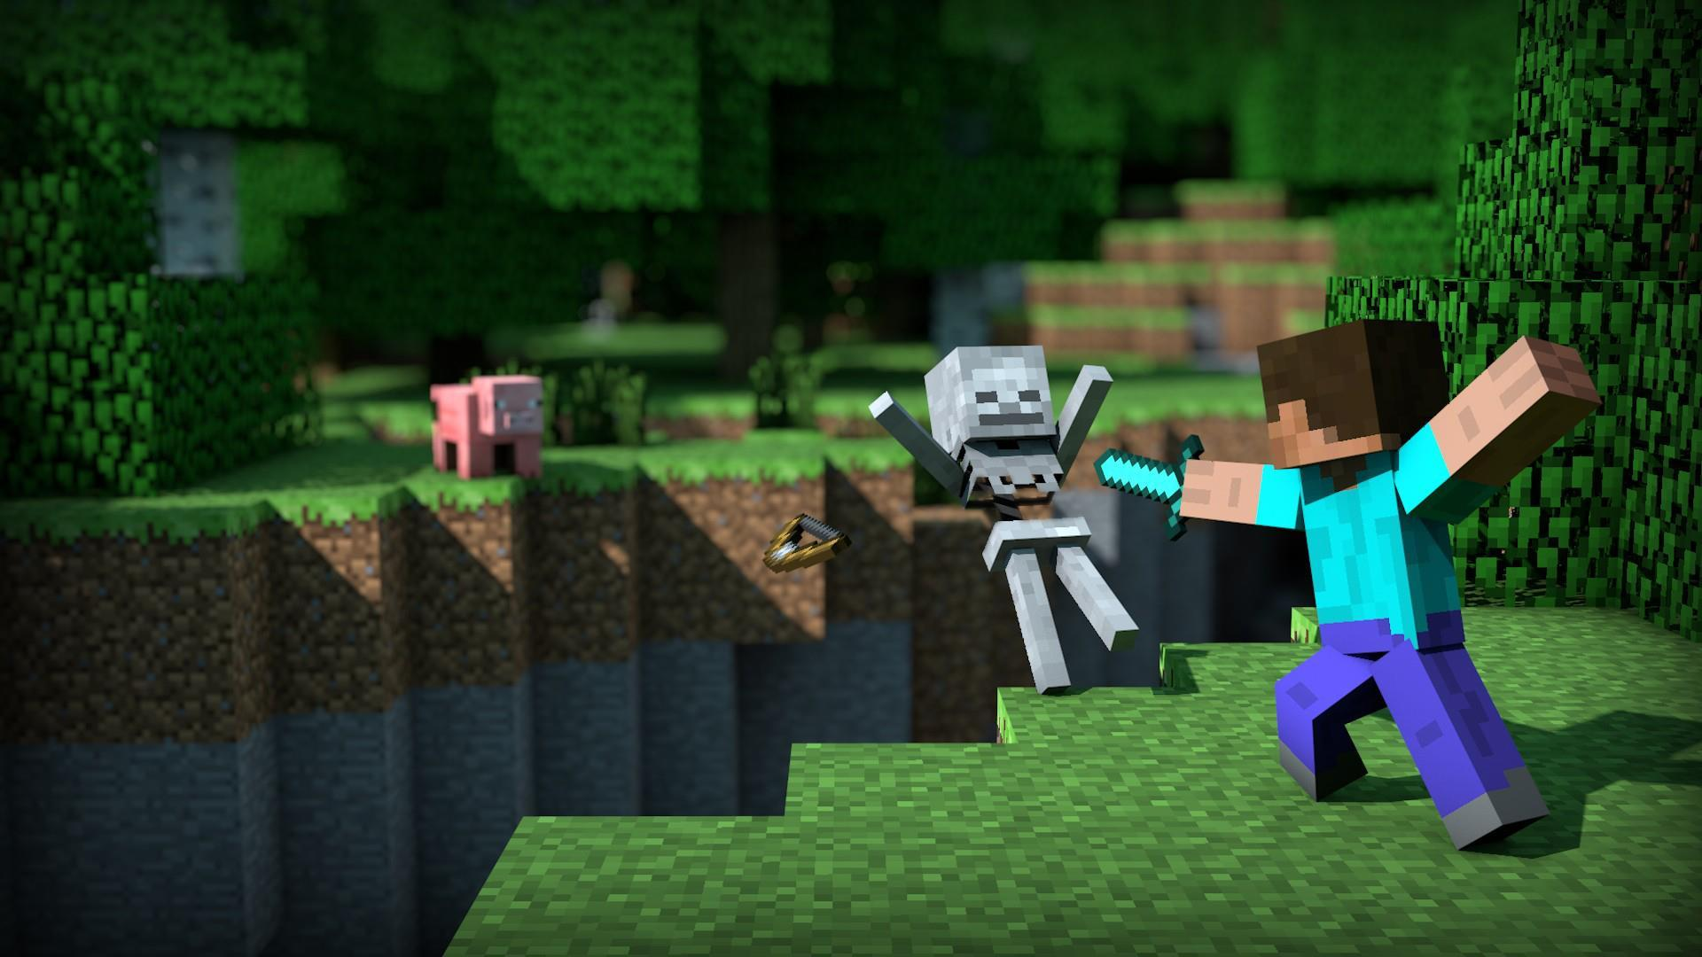

**Project Sponsored by Companies**

 **IITB**: Frontend for SPAN (Synergistic Program ANalyzer)

 **KJS Medical College**: Diabetic Retinopathy Identification

**PhD Pursuing Faculties**

 Mrs. Sarita Ambadekar

 Mrs. Shyamal Vidnorkar